What Is Apache Spark?
Apache Spark is a cluster computing platform designed to be fast and general-purpose.
Spark extends the popular MapReduce model to efficiently support more types of computations, including interactive queries and stream processing.

driver program: launch various parallel operations on a cluster

Driver programs access Spark through a SparkContext object, which represents a connection to a computing cluster. In the shell, a SparkContext is automatically created for you as the variable called sc.

driver programs typically manage a number of nodes called executors.

resilient distributed dataset (RDD): An RDD in Spark is simply an immutable distributed collection of objects. Each RDD is split into multiple partitions, which may be computed on different nodes of the cluster.

Users create RDDs in two ways: by loading an external dataset, or by distributing a collection of objects (e.g., a list or set) in their driver program.

RDDs offer two types of operations: transformations and actions.
Transformations construct a new RDD from a previous one. For example, one common transformation is filtering data that matches a predicate.
Actions, on the other hand, compute a result based on an RDD, and either return it to the driver program or save it to an external storage system (e.g., HDFS).

Although you can define new RDDs any time, Spark computes them only in a lazy fashion—that is, the first time they are used in an action. For the first() action, Spark scans the file only until it finds the first matching line; it doesn’t even read the whole file.

Spark’s RDDs are by default recomputed each time you run an action on them. If you would like to reuse an RDD in multiple actions, you can ask Spark to persist it using RDD.persist(). After computing it the first time, Spark will store the RDD contents in memory (partitioned across the machines in your cluster), and reuse them in future actions.

Transformations
Transformed RDDs are computed lazily -- Spark will not begin to execute until it sees an action. Rather than thinking of an RDD as containing specific data, it is best to think of each RDD as consisting of instructions on how to compute the data that we build up through transformations.

inputRDD = sc.textFile("log.txt")
errorsRDD = inputRDD.filter(lambda x: "error" in x)

errorsRDD = inputRDD.filter(lambda x: "error" in x)
warningsRDD = inputRDD.filter(lambda x: "warning" in x)
badLinesRDD = errorsRDD.union(warningsRDD)

Actions
print "Input had " + badLinesRDD.count() + " concerning lines"
print "Here are 10 examples:"
for line in badLinesRDD.take(10):
print line

RDDs also have a collect() function to retrieve the entire RDD.
Keep in mind that your entire dataset must fit in memory on a single machine to use collect() on it, so collect() shouldn’t be used on large datasets.

When you pass a function that is the member of an object, or contains references to fields in an object (e.g., self.field ), Spark sends the entire object to worker nodes, which can be much larger than the bit of information you need (see Example 3-19). Sometimes this can also cause your program to fail, if your class contains objects that Python can’t figure out how to pickle.

Element-wise transformations
The map() transformation takes in a function and applies it to each element in the RDD with the result of the function being the new value of each element in the resulting RDD.
nums = sc.parallelize([1, 2, 3, 4])
squared = nums.map(lambda x: x * x).collect()
for num in squared:
print "%i " % (num)

The filter() transformation takes in a function and returns an RDD that only has elements that pass the filter() function.

If we want to produce multiple output elements for each input element. The operation to do this is called flatMap() .
lines = sc.parallelize(["hello world", "hi"])
words = lines.flatMap(lambda line: line.split(" "))
words.first() # returns "hello"

Action
reduce() has to return the result with the same type

Example 3-35. aggregate() in Python
sumCount = nums.aggregate((0, 0),
(lambda acc, value: (acc[0] + value, acc[1] + 1),
(lambda acc1, acc2: (acc1[0] + acc2[0], acc1[1] + acc2[1]))))
return sumCount[0] / float(sumCount[1])

Persistence (Caching)
If we do this naively, Spark will recompute the RDD and all of its dependencies each time we call an action on the RDD. This can be especially expensive for iterative algorithms, which look at the data many times.
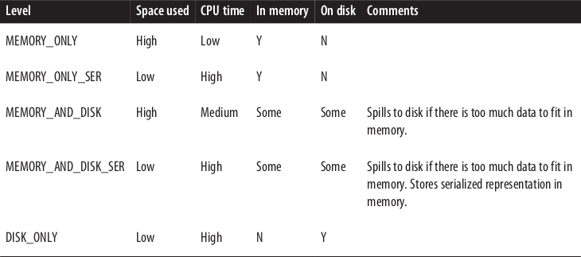

MLlib
HashingTF: builds term frequency feature vectors from text data
LogisticRegressionWithSGD: implements the logistic regression procedure using stochastic gradient descent (SGD)

